A000- Afr-Gabon-Kota Mbulu-ngula Reliquary Figure-Brass-late 19th c

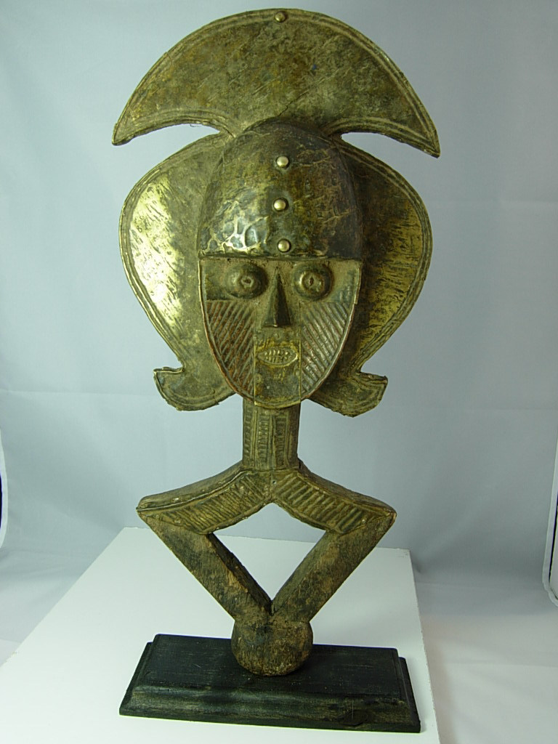

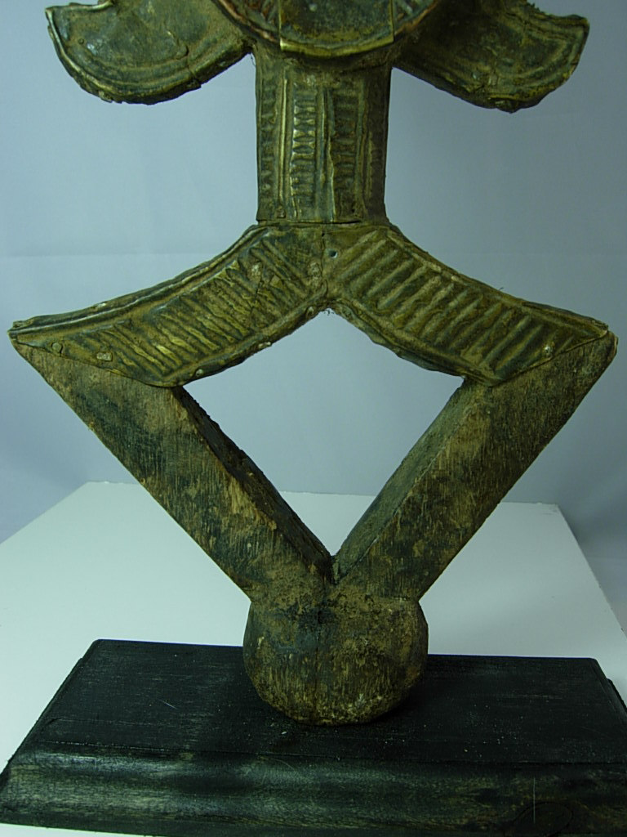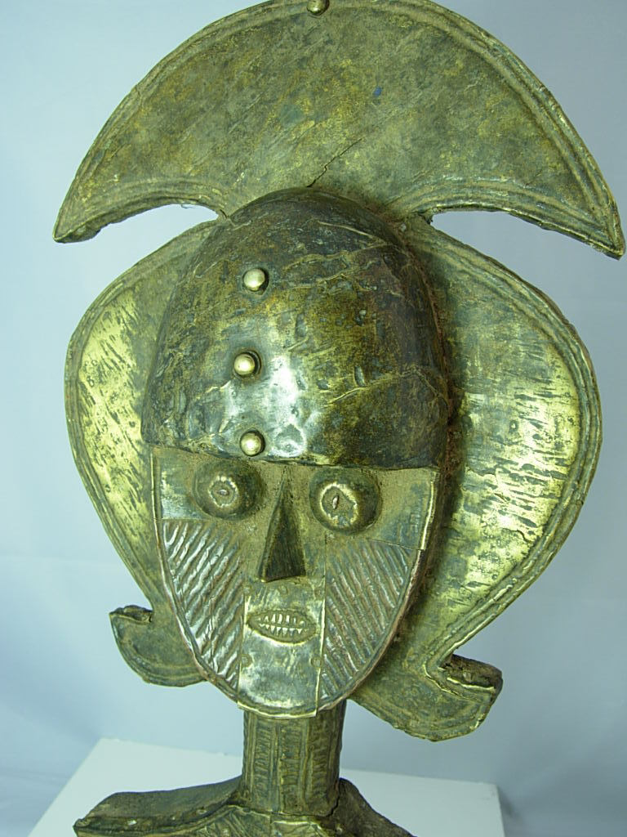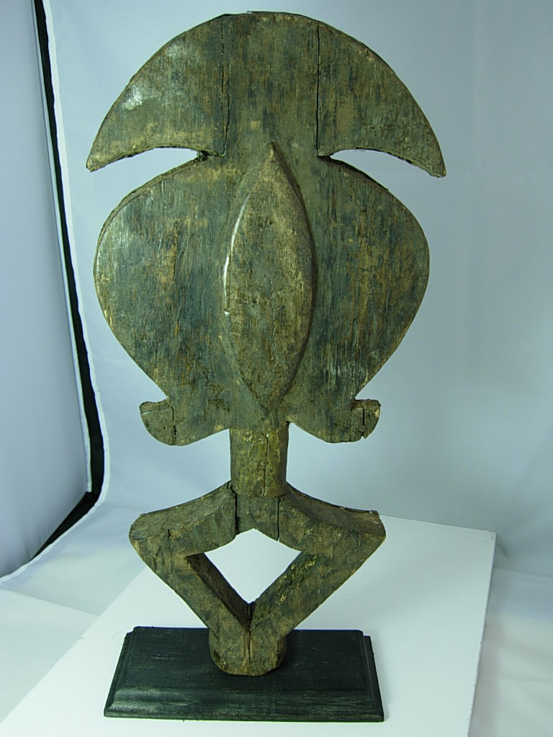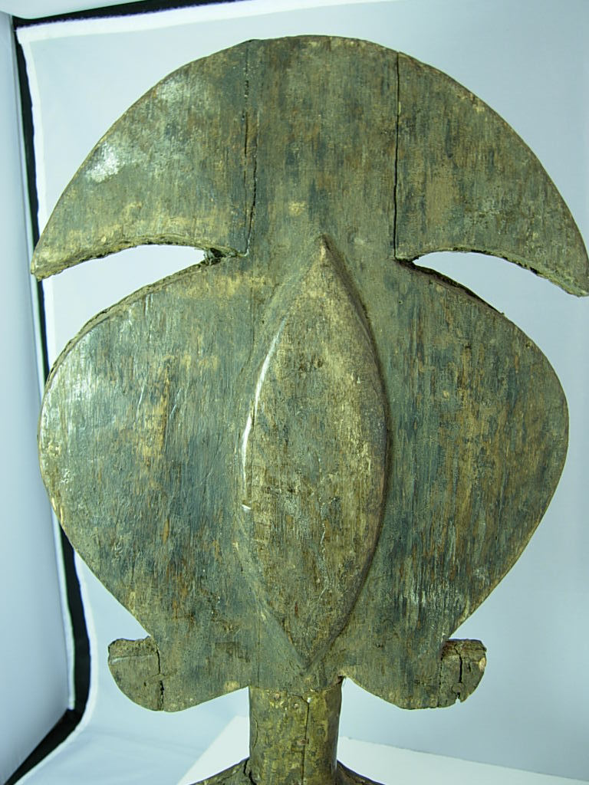

Figs. 1-5. Afr-Gabon-Kota Mbulu-ngula Reliquary Figure-Brass-late 19th c

Case No.: 6

**Accession No.**

**Formal Label:** Afr-Gabon-Kota Mbulu-ngula Reliquary Figure-Brass-late 19th c

**Display Description:**

The Kota revere the relics of ancestors. Ancestor worship formed the core of the family group’s religious and social life. At the death of a chief, the initiates would take from the body of the deceased various relics, which were then decorated with metal and rubbed with powders of multiple magical powers. The Kota have produced large quantity of statues of ancestors with the diamond-shaped lower part called mbulu-ngulu; these rather two-dimensional sculptures are in wood; symbolic metals were applied to the upper part in strips or sheets to add power. Copper in particular was identified with longevity and power. These statues stood guard in cylindrical bark boxes, on baskets or bundles called bwete that contained the skulls and bones of important ancestors. Bound into a packet and lashed to the base of a carved figure, the bones formed a stable base that allowed the image to stand more or less upright. Thanks to the diversity of the groups, scattered over a vast area, a great variety of different styles of figures has developed, some of them endogenous and some influenced by neighboring styles. Kota figures represent an extremely stylized human body, reduced to shoulders and “arms,” in emptied lozenge shape, surmounted by a large face framed by an ample coiffure with hanging tresses. The face, always oval, may be concave (female), convex (male) or concave-convex, with a forehead in quarter-sphere (also male). The reliquaries were kept outside the homes, in huts at the edge of the village. Only the initiates of the lineage had access to this sacred place. At the time of initiation in the reliquary cult, the clans would meet to perform communal rituals; each clan’s chief would dance holding the reliquary. Some reliquaries featured a large figure representing the lineage founder along with some smaller figures representing his successors. There are figures with two identical or different faces made on two opposite sides of the flat head.

**LC Classification:**

**Date or Time Horizon:** late 19th c

**Geographical Area:**

**Map:**

**GPS coordinates:**

**Cultural Affiliation:**

**Media:** Please note, the back will show repairs (staples) to secure the tips that became detached but cannot be seen from the front. Secured on a wooden base.

**Dimensions:** 18 inches high.

**Weight:**

**Condition:**

**Provenance:**

**Discussion:**

**References:**